Name: __________________________________________ Block: 1st, 3rd, or 4th Week of: September 9th – 13th, 2013
Monday Sept. 9th | Tuesday Sept. 10th | Wednesday Sept. 11th | Thursday Sept. 12th | Friday Sept. 13th
What is the value of  $$-13-(-18)$$ | What is the value of  $$14-(-10)$$ | What is the value of  $$3-7$$ | What is the value of  $$-12-7$$ | What is the value of  $$-8-(-5)$$
Order from least to greatest:  $$0.2, \frac{4}{5}, 10\%$$ | Order from least to greatest:  $$\frac{1}{2},\frac{2}{8},\frac{4}{5}$$ | Order from least to greatest:  $$0.75, 20\%,\frac{1}{3}$$ | Order from least to greatest:  $$\frac{1}{4},15\%, 0.9$$ | Order from least to greatest:  $$\frac{3}{5},0.2, 80\%$$
Write a number sentence represented by the model  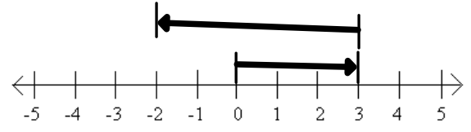  $$______+______=______$$ | Write a number sentence represented by the model  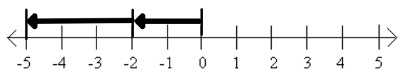  $$______+______=______$$ | Write a number sentence represented by the model  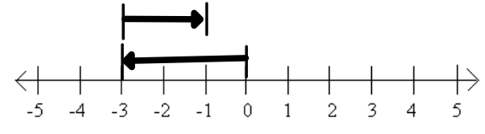  $$______+______=______$$ | Write a number sentence represented by the model  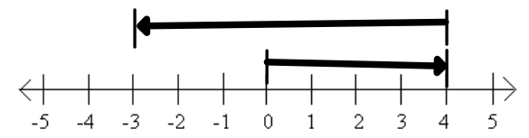  $$______+______=______$$ | Write a number sentence represented by the model  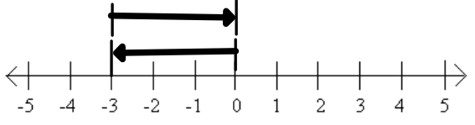  $$______+______=______$$
A team gained 5 yards on their first play of the game. Then they lost 6 yards. Find the total change in yardage. | Roger owes his mom $5. He borrows another $6 from her. | A roller coaster begins at 90 feet above ground level. Then it descends 105 feet. Find the height of the coaster after the first descent. | The average temperature in Calgary, Canada, is 22˚C in July and –11˚C in January. Find the range of the highest and lowest temperatures in Calgary. | A cyclist travels downhill for  125 feet. Then she travels up a hill 50 feet.

