Name: __________________________________________ Block: 1st, 3rd, or 4th Week of: September 2nd – 6th, 2013
Monday 2nd | Tuesday 3rd | Wednesday 4th | Thursday 5th | Friday 6th
Labor Day  No School  No Problems | 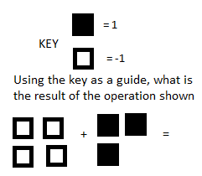 | 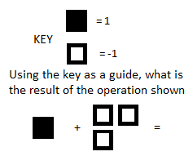 | 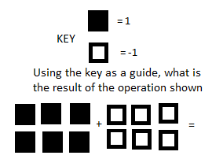 | 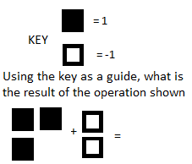
Labor Day  No School  No Problems | Evaluate the expression: | Evaluate the expression: | Evaluate the expression: | Evaluate the expression:
Labor Day  No School  No Problems | Order from least to greatest:  $$\left\{0.5, 4, -3, -2\right\}$$  _____<_____<_____<_____ | Order from greatest to least:  $$\left\{-1, 0, -4, 4\right\}$$  _____>_____>_____>_____ | Order from greatest to least:  $$\left\{-23, -45, 2, 1\right\}$$  _____>_____>_____>_____ | Order from least to greatest:  $$\{\frac{1}{2}, -7, -8, 0\}$$  _____<_____<_____<_____
Labor Day  No School  No Problems | Convert to a decimal.  $$\frac{7}{10}=$$ | Convert to a fraction. Simplify  $$0.025=$$ | Convert to a decimal.  $$\frac{3}{20}=$$ | Convert to a fraction. Simplify  $$0.04=$$

