1) Identify each arithmetic sequence below:  A) $2, 4, 8, 16, …$  B) $1, -10, 100, -1000, …$  C) $10, 20, 30, 40, …$  D) 19, 17, 15, 12, …  E) $-10, -8, -6, -4, …$  F) $5, 3, 1, -1, …$ | 2) Identify each geometric sequence below:  A) $3, 9, 27, 81, …$  B) $-2, -4, -6, -8, …$  C) $110, 210, 310, 410, …$  D) $1, 4, 40, 100, …$  E) $-1000, 100, -10, 1, …$  F) $1,\frac{1}{2},\frac{1}{4},\frac{1}{8},\frac{1}{16},…$ | 3)  An arithmetic sequence has a common __________________.  A geometric sequence has a common ___________________.
4) Write a variable expression that describes the relationship between consecutive terms in this sequence:  $$5, -25, 125, -625, …$$ | 5) Kathy made an arithmetic sequence with consecutive terms related by this rule:  $$n+(-3)$$  Which of these is Kathy’s sequence?  $$A) 13, 16, 19, 22, …$$  $$B) 6, 3, 0, -3, …$$  $$C) 3333, 333, 33, 3, …$$  $$D)-9, -6, -3, 0, …$$ | 6) Michelle wrote this variable expression to describe the relationship between consecutive terms in her sequence: 0.5n  $$\frac{1}{2}n$$  Which is Michelle’s sequence?  $$A) 5, 10, 15, 20, …$$  B) $\frac{1}{2}, 1,\frac{3}{2}, 2, …$  $$C) 24, 12, 6, 3, …$$  D) $3, 6, 12, 24, …$
7) What will be the next term in each sequence below:  $128, 32, 8, 2,$ ________  $5, 7.5, 10, 12.5,$________  $1, -4, 16, -64,$________ | 8) Fill in the terms in this sequence that starts with $1$ and has a common ratio of $-10$:  $1,$______, _________, _________, __________, …  What weird thing happens when you have a common ratio that is negative? | 9)  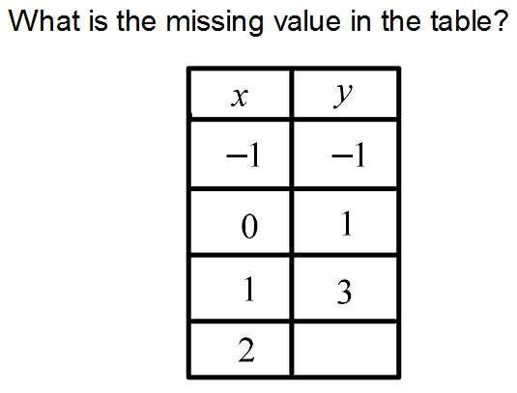

10)  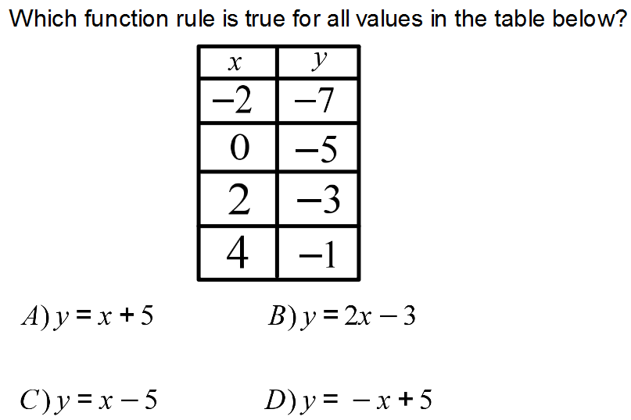 | 11) Which graph represents the values in the function table?  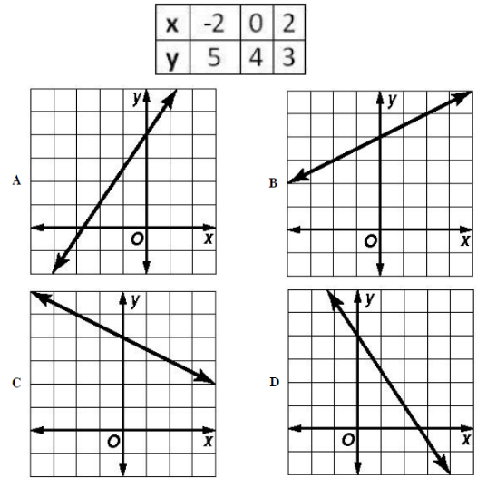 | 12)  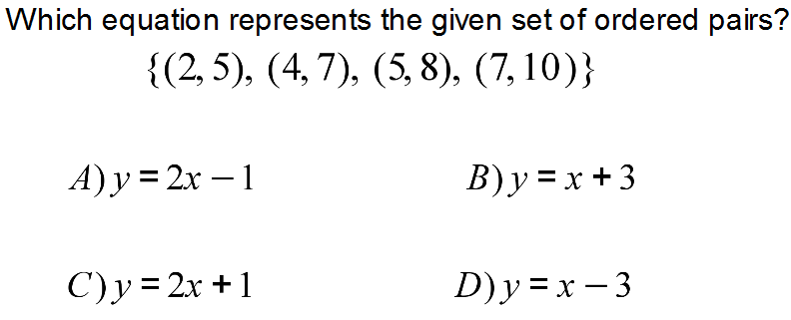
13)  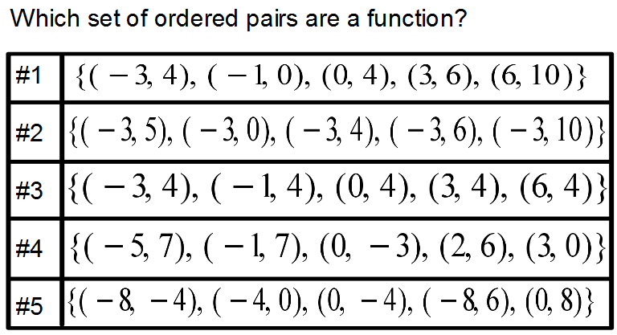 | 14)  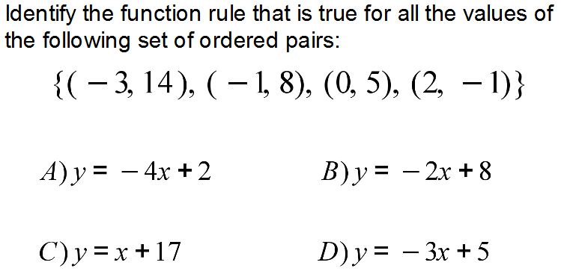 | 15)  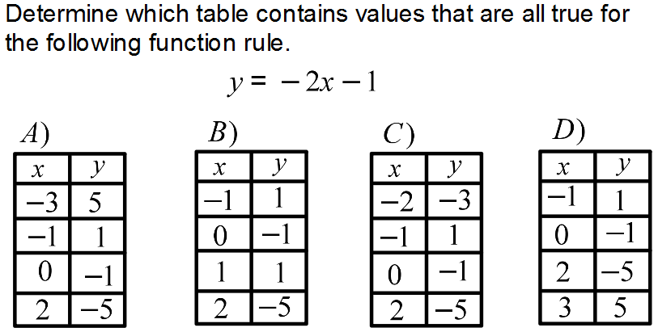

16) Which function rule is represented by the graph below:  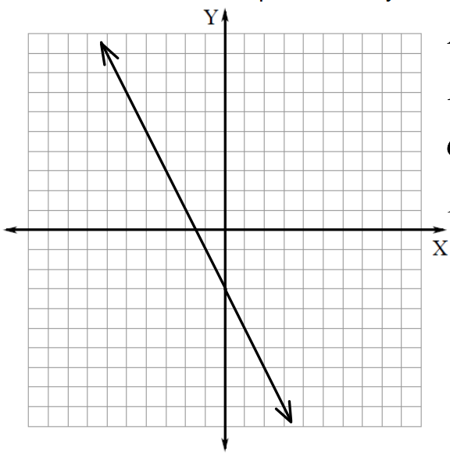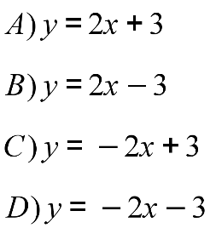 | 17) Match each function rule with the correct table of values:  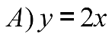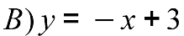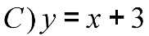  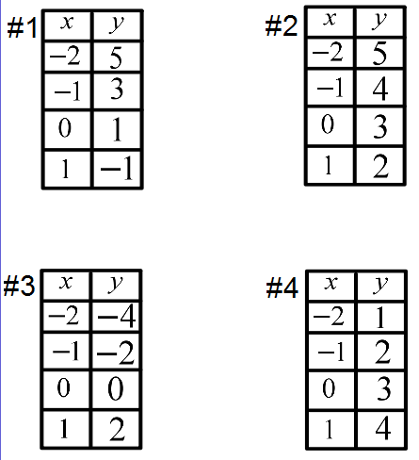
18) Which graph contains the values that satisfy the following function?  $$y=-x+2$$  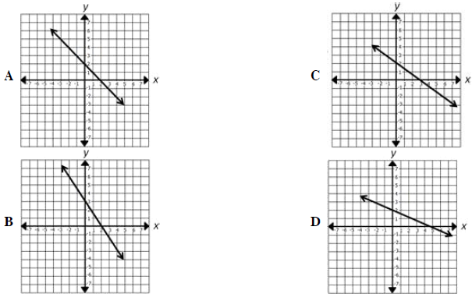 | 19)  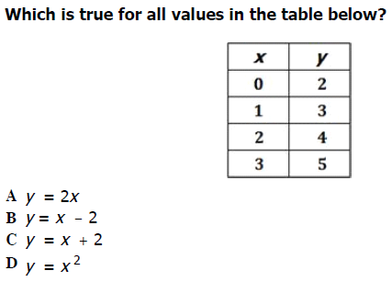

20) Look at the table:  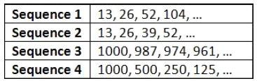  Which sequence has a common ratio of $2$? | 21) Look at the table:  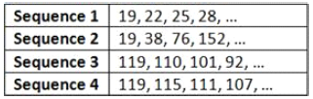  Which sequence has a common difference of $-9$?
22)  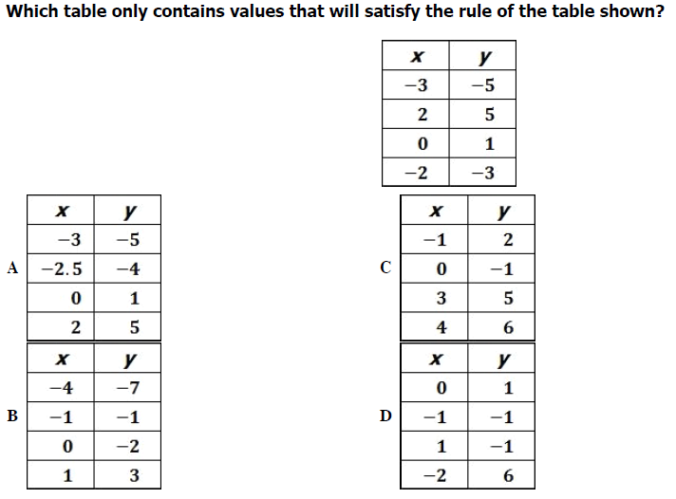 | 23) A number machine uses a rule to change numbers into different numbers. The following picture shows what happens when three different numbers go into and come out of the same number machine.  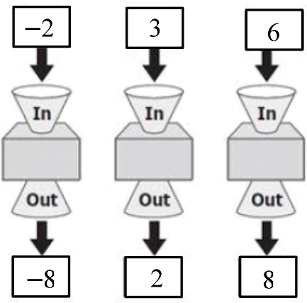  What appears to be the rule used by the number machine?  A) $y=3x-2$  B) $y=x-1$  C) $y=2x-4$  D) $y=-2x-4$

