Adding, Subtracting, Multiplying, and Dividing Integers Rules
Adding Integers:
- If the signs are the same; keep the sign of the two addends and add
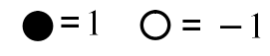
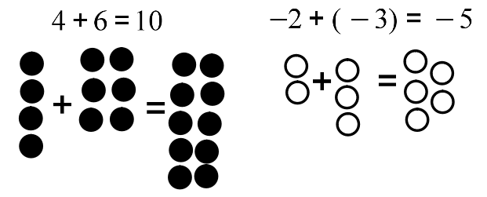
- If the signs are different, keep the sign of the larger absolute value (the one farther from zero) and subtract
Subtracting Integers:
- “Add the Opposite”
  - 1) Change the operation to addition
  - 2) Change the sign of the subtrahend to its opposite
  - 3) Follow the rules for addition

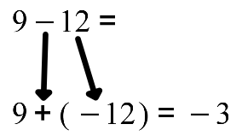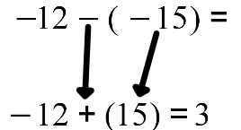

Multiplication and Division of Integers:
Multiplying Integers:
- SAME SIGNS:
  - The product is always positive
    - $2×6=12$
    - $-4\left(-3\right)=\left(-12\right)$
- DIFFERENT SIGNS:
  - The product is always negative
    - $-2\left(4\right)=-8$
    - $3\left(-1\right)=-3$

Dividing Integers:
- SAME SIGNS:
  - The quotient is always positive
    - $-12÷(-2)=6$
    - $6÷3=2$
- DIFFERENT SIGNS:
  - The quotient is always negative
    - $-12÷3=-4$
    - $2÷\left(-1\right)=-2$

