Warm-Up November 8th: Name:
1) Evaluate the following expression:  $$4^{2}+3\left[-7-\left(-10\right)\right]-8$$ | 2) Micah wants to cover his square gaming console with square Xbox stickers. If he uses exactly 324 stickers, which could be the length of one side of the table?  A) 162 stickers  B) 17 stickers  C) 19 stickers  D) 18 stickers
3) Write the following numbers in scientific notation:  $975,000,000$  $0.0003024$  $0.0512$  $40,320,000,000$ | 4) Tatiana is going to create a sequence with the common difference of $6$. She wants to ensure that the number $45$ is included in her sequence. Which number could she choose to begin her sequence with?  A) 5  B) 4  C) 3  D) 2
Warm-Up November 8th: Name:
1) Evaluate the following expression:  $$4^{2}+3\left[-7-\left(-10\right)\right]-8$$ | 2) Micah wants to cover his square gaming console with square Xbox stickers. If he uses exactly 324 stickers, which could be the length of one side of the table?  A) 162 stickers  B) 17 stickers  C) 19 stickers  D) 18 stickers
3) Write the following numbers in scientific notation:  $975,000,000$  $0.0003024$  $0.0512$  $40,320,000,000$ | 4) Tatiana is going to create a sequence with the common difference of $6$. She wants to ensure that the number $45$ is included in her sequence. Which number could she choose to begin her sequence with?  A) 5  B) 4  C) 3  D) 2
5) Identify each sequence that has a common ratio of $\frac{1}{2}$.  $$7, 14, 28, 56, …$$  $$100, 50, 25, 12.5, …$$  $$\frac{1}{2}, 1, 1\frac{1}{2}, 2, 2\frac{1}{2}, …$$  $$8, 4, 2, 1,\frac{1}{2}$$ | 6) Translate the following phrases.  “twelve less a number is equal to eight”  “seven more than the quotient of a number and two”  “three less than the product of five and a number is ten
7) Which property is illustrated by the following number sentences:  $3+\left(-3\right)-4=0-4$  $1+5*0*2=1+0*2$  $4-\left(6+0\right)=4-6$  $8+3+2*1=8+3+2$  Word Bank: Commutative, Associative, Distributive, + identity, x identity, + inverse, x inverse, and multiplicative property of zero. | 8) Graph the relation:  $$\left\{\left(4, -3\right), \left(-5, -1\right), \left(0, 3\right), \left(4, 0\right)\right\}$$  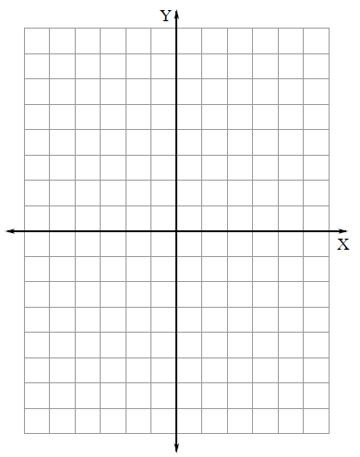

5) Identify each sequence that has a common ratio of $\frac{1}{2}$.  $$7, 14, 28, 56, …$$  $$100, 50, 25, 12.5, …$$  $$\frac{1}{2}, 1, 1\frac{1}{2}, 2, 2\frac{1}{2}, …$$  $$8, 4, 2, 1,\frac{1}{2}$$ | 6) Translate the following phrases.  “twelve less a number is equal to eight”  “seven more than the quotient of a number and two”  “three less than the product of five and a number is ten
7) Which property is illustrated by the following number sentences:  $3+\left(-3\right)-4=0-4$  $1+5*0*2=1+0*2$  $4-\left(6+0\right)=4-6$  $8+3+2*1=8+3+2$  Word Bank: Commutative, Associative, Distributive, + identity, x identity, + inverse, x inverse, and multiplicative property of zero. | 8) Graph the relation:  $$\left\{\left(4, -3\right), \left(-5, -1\right), \left(0, 3\right), \left(4, 0\right)\right\}$$

