Warm-Up November 6th: Name:
1) Identify each expression that is equivalent to $-5$:  $$0-5$$  $$-1*\left(-5\right)$$  $$-7-2$$  $$-25÷5$$  $$-2-3$$ | 2) Evaluate the following expression:  $$-4\left(5-\left|-4\right|\right)-3^{2}$$
3) Penelope wants to cover a square table with Adventure Time tiles. If she uses exactly 196 tiles, which could be the length of one side of the table?  A) 98 tiles  B) 4 tiles  C) 14 tiles  D) 49 tiles | 4)  Part A) The diameter of a red blood cell is $0.00045$ inches. How could this number be expressed in scientific notation?  Part B) Finn learned there were about $7.4×{10}^{5}$ candy people in the Candy Kingdom. How could Finn express this number in standard notation?
Warm-Up November 6th: Name:
1) Identify each expression that is equivalent to $-5$:  $$0-5$$  $$-1*\left(-5\right)$$  $$-7-2$$  $$-25÷5$$  $$-2-3$$ | 2) Evaluate the following expression:  $$-4\left(5-\left|-4\right|\right)-3^{2}$$
3) Penelope wants to cover a square table with Adventure Time tiles. If she uses exactly 196 tiles, which could be the length of one side of the table?  A) 98 tiles  B) 4 tiles  C) 14 tiles  D) 49 tiles | 4)  Part A) The diameter of a red blood cell is $0.00045$ inches. How could this number be expressed in scientific notation?  Part B) Finn learned there were about $7.4×{10}^{5}$ candy people in the Candy Kingdom. How could Finn express this number in standard notation?
5) Order from least to greatest:  $$\frac{3}{7} 0.073 73\% 7.3×{10}^{-3}$$ | 6) Write an expression to represent each phrase:  “nine less than the quotient of a number and seven is fourteen”  “The product of six and a number decreased by one is ten”
7) Name the property illustrated by each equation:  $-4+7=7+(-4)$  $-3\left(m+5\right)=-3m+(-15)$  $\frac{2}{3}*\frac{3}{2}=1$  $-9+0=(-9)$ | 8) Plot the following points on the coordinate plane:  $\{\left(-3, 5\right), \left(0, -3\right), \left(2,-4\right), (-4, 0)$}  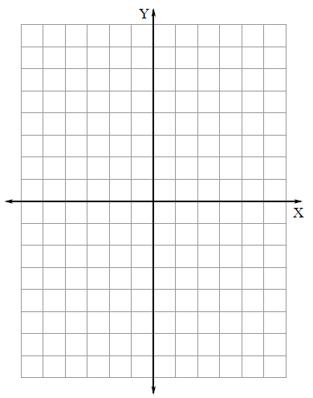

5) Order from least to greatest:  $$\frac{3}{7} 0.073 73\% 7.3×{10}^{-3}$$ | 6) Write an expression to represent each phrase:  “nine less than the quotient of a number and seven is fourteen”  “The product of six and a number decreased by one is ten”
7) Name the property illustrated by each equation:  $-4+7=7+(-4)$  $-3\left(m+5\right)=-3m+(-15)$  $\frac{2}{3}*\frac{3}{2}=1$  $-9+0=(-9)$ | 8) Plot the following points on the coordinate plane:  $$\{\left(-3, 5\right), \left(0, -3\right), \left(2,-4\right), (-4, 0)\}$$

