Name: ______________________________________________________ Block: 1st, 3rd, or 4th Week of: November 18th – 22nd, 2013
Monday Nov. 18th | Tuesday Nov. 19th | Wednesday Nov. 20th | Thursday Nov. 21st | Friday Nov. 22nd
Convert to a fraction and simplify:  $$0.16$$ | Convert to a fraction and simplify:  $$0.025$$ | Convert to a fraction and simplify:  $$0.8$$ | Convert to a fraction and simplify:  $$0.56$$ | History Field Trip Today  Turn in warm-up on Thursday.
Solve for $x$.  $$x+27=48$$ | Solve for $x$.  $$x-15=30$$ | Solve for $x$.  $$x+34=57$$ | Solve for $x$.  $$x-24=13$$ | History Field Trip Today  Turn in warm-up on Thursday.
Determine if the sequence is arithmetic or geometric and find the common difference or common ratio.  $$-12, -8, -4, 0, …$$ | Determine if the sequence is arithmetic or geometric and write a variable expression that represents the sequence.  $$64, 32, 16, 8, …$$ | Determine if the sequence is arithmetic or geometric and find the common difference or common ratio.  $$-6, 24, -96, 384, …$$ | Determine if the sequence is arithmetic or geometric and write a variable expression that represents the sequence.  $$36, 30, 24, 18, …$$ | History Field Trip Today  Turn in warm-up on Thursday.
Problem #4 is on the back of the sheet. | Problem #4 is on the back of the sheet. | Problem #4 is on the back of the sheet. | Problem #4 is on the back of the sheet. | History Field Trip Today  Turn in warm-up on Thursday.

Monday November 18th  Which function rule is represented by the graph below?  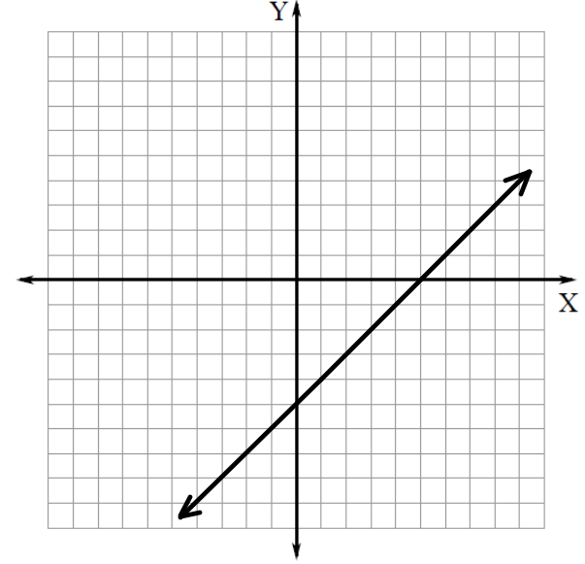  $$A) y=x+5 B) y=x-5 C) y=-x+5 D) y=-x-5$$ | Tuesday November 19th  Which function rule is represented by the graph below?  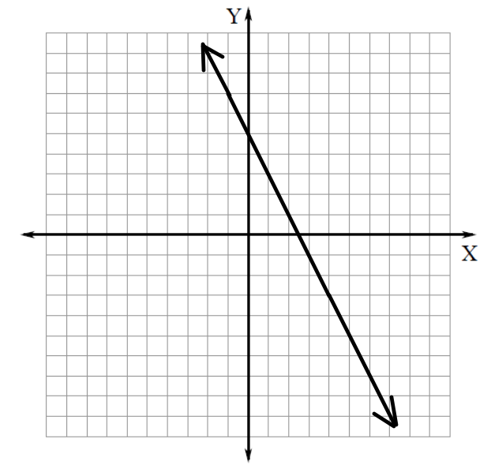  $$A) y=2x+5 B) y=2x-5 C) y=-2x+5 D) y=-2x-5$$
Wednesday November 20th  Which function rule is represented by the graph below?  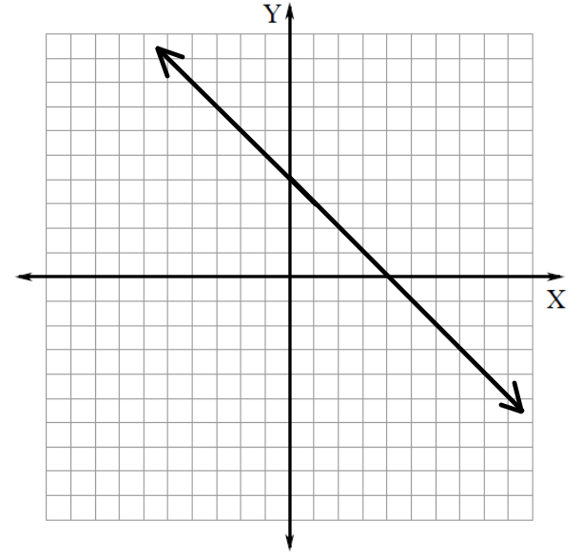  $$A) y=x+4 B) y=x-4 C) y=-x+4 D) y=-x-4$$ | Thursday November 21st  Which function rule is represented by the graph below?  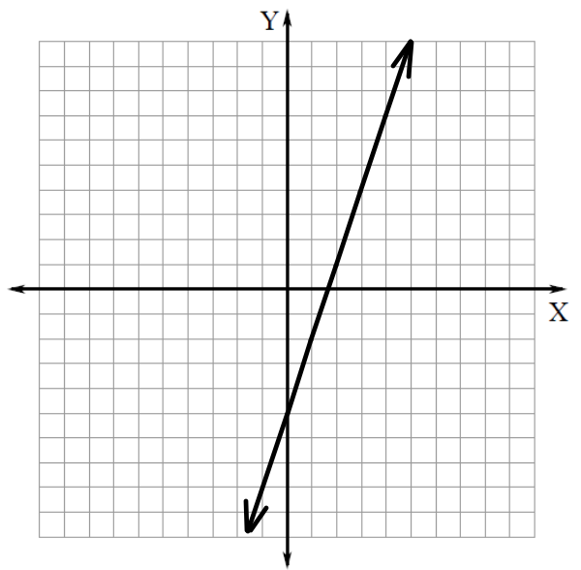  $$A) y=3x+5 B) y=3x-5 C) y=-3x+5 D) y=-3x-5$$

