Name: __________________________________________ Block: 1st, 3rd, or 4th Week of: March 24th – 28th, 2014
Monday | Tuesday | Wednesday | Thursday | Friday
1) Circle all of the following quadrilaterals that have four congruent sides and four right angels:  Quadrilateral Trapezoid  Parallelogram Rectangle  Rhombus Square | 1) Circle all of the following quadrilaterals that have 1 pair of opposite sides are parallel:  Quadrilateral Trapezoid  Parallelogram Rectangle  Rhombus Square | 1) Circle all of the following quadrilaterals that have no right angles and all four sides are congruent:  Quadrilateral Trapezoid  Parallelogram Rectangle  Rhombus Square | 1) Circle all of the following quadrilaterals that have opposite sides are congruent and four right angles:  Quadrilateral Trapezoid  Parallelogram Rectangle  Rhombus Square | 1) Circle all of the following quadrilaterals that have opposite sides are parallel and congruent and have no right angles:  Quadrilateral Trapezoid  Parallelogram Rectangle  Rhombus Square
2) Which of the following is the better buy?  A) 16oz. for $0.80  B) 20oz. for $1.23 | 2) Which of the following is the better buy?  A) 15 pencils for $5  B) 35 pencils for $7 | 2) Which of the following is the better buy?  A) 120 grams for $8.50  B) 80 grams for $6 | 2) Which of the following is the better buy?  A) 40 grapes for $3.50  B) 90 grapes for $7.25 | 2) Which of the following is the better buy?  A) 75 staples for $2.65  B) 50 staples for $2.10
3) Name three possible solutions to the following inequality:  $$85≤-5a$$ | 3) Name three possible solutions to the following inequality:  $$-36>-4n$$ | 3) Name three possible solutions to the following inequality:  $$156≥-12v$$ | 3) Name three possible solutions to the following inequality:  $$-81<-9x$$ | 3) Name three possible solutions to the following inequality:  $$-33>-3x$$
4) A pair of Lebron 11’s originally cost $250. They are on sale for 20% off. You have $175 to spend. Do you have enough money to buy the pair of shoes? | 4) The Wii U cost $199. It is on sale for 15% off. You have $170 to spend. Do you have enough money to buy the Wii U? | 4) Alt-J’s album “An Awesome Wave” cost $14.50. It is on sale for 25% off. You have $10 to spend. Do you have enough money to buy the album? | 4) A SouthFace jacket cost $55. It is on sale for 30% off. You have $37 to spend. Do you have enough money to buy the jacket? | 4) A 6-foot gaint sub from Subway cost $40. You have a coupon for 20% off. You have $33 to spend. Do you have enough money to buy the gaint sub?

Helpful Examples To Look to for Help:
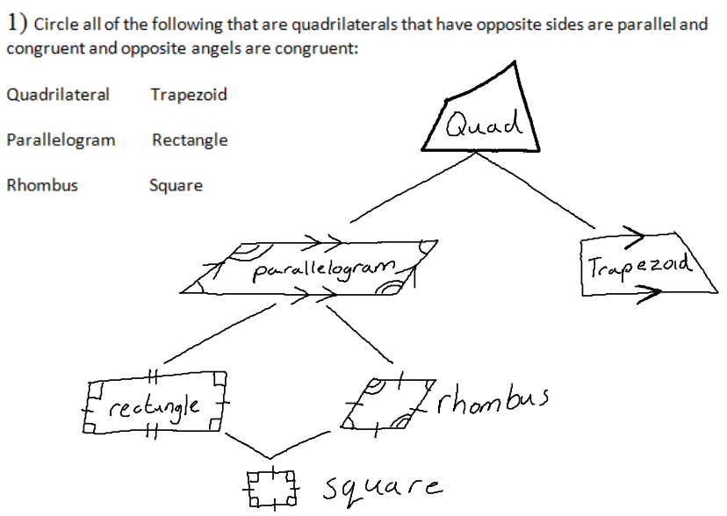 | 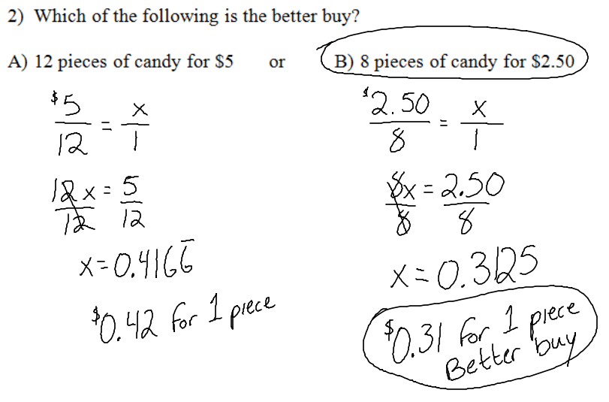
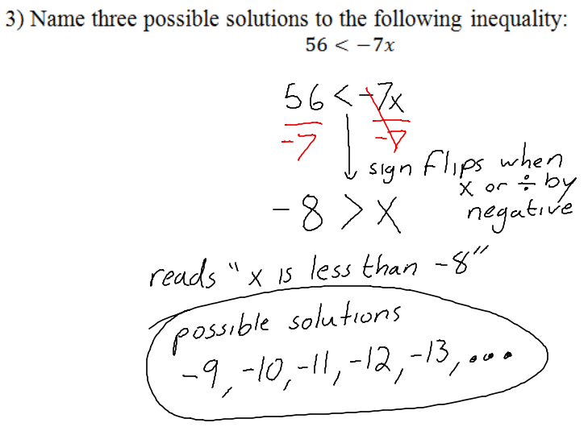 | 