Name: __________________________________________ Block: 1st, 3rd, or 4th Week of: March 17th – 21st, 2014
Monday | Tuesday | Wednesday | Thursday | Friday
1) Which value of x makes the following true? Show work!  $$-3x<-12$$  $$A) 4 B) 3 C) 5$$ | 1) Which value of x makes the following true? Show work!  $$4+x<10$$  $$A) 3 B) 6 C) 8$$ | 1) Which value of x makes the following true? Show work!  $$x-8>-5$$  $$A)-13 B) 4 C) 3$$ | 1) Which value of x makes the following true? Show work!  $$-2x>16$$  $$A)-8 B)-9 C)-7$$ | 1) Which value of x makes the following true? Show work!  $$-4x<28$$  $$A)-7 B)-5 C)-9$$
2) Tony called his mom long distance. The first 5 minutes cost $4, and each minute after that cost $0.30. How much did it cost if they talked for 10 minutes? | 2) A taxi charges $10 for the first 3 miles, and each mile after that cost $2. How much does it cost to travel 12 miles? | 2) Joe called his bro long distance. The first 4 minutes cost $3, and each minute after that cost $0.25. How much did it cost if they talked for 13 minutes? | 2) Verizon data plan charges $15 for the first 2 GB, and each GB after that cost $7. How much would your phone bill be if you used 7 GB? | 2) AT&T data plan charges $20 for the first 2 GB, and each GB after that cost $4. How much would your phone bill be if you used 8 GB?
3) Which property of operations is illustrated by the following number sentence?  $$5*0=8$$ | 3) Which property of operations is illustrated by the following number sentence?  $$\frac{4}{5}*1=\frac{4}{5}$$ | 3) Which property of operations is illustrated by the following number sentence?  $$\left(4+3\right)+2=\left(3+4\right)+2$$ | 3) Which property of operations is illustrated by the following number sentence?  $$5\left(x-2\right)=5x-10$$ | 3) Which property of operations is illustrated by the following number sentence?  $$6+\left(-6\right)=0$$
4) WITHOUT CALCULATOR  Evaluate the expression.  $$|3^{2}-15|$$ | 4) WITHOUT CALCULATOR  Evaluate the expression.  $$4+|-2^{2}-6|$$ | 4) WITHOUT CALCULATOR  Evaluate the expression.  $$|-10+2\left(3\right)|$$ | 4) WITHOUT CALCULATOR  Evaluate the expression.  $$-3+|{\left(-3\right)}^{3}|$$ | 4) WITHOUT CALCULATOR  Evaluate the expression.  $$5+|-7+{\left(-2\right)}^{2}|$$

Helpful Examples To Look to for Help:
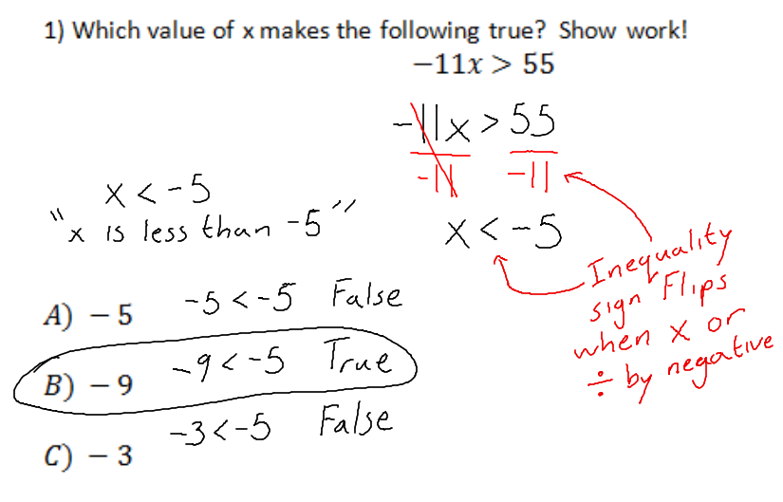 | 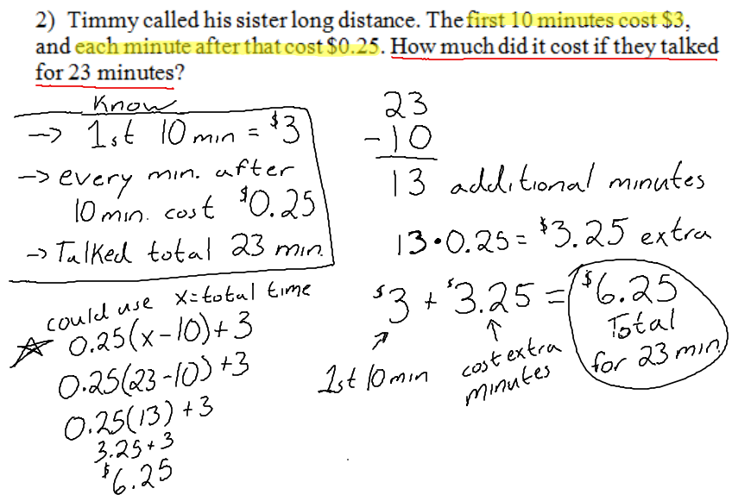
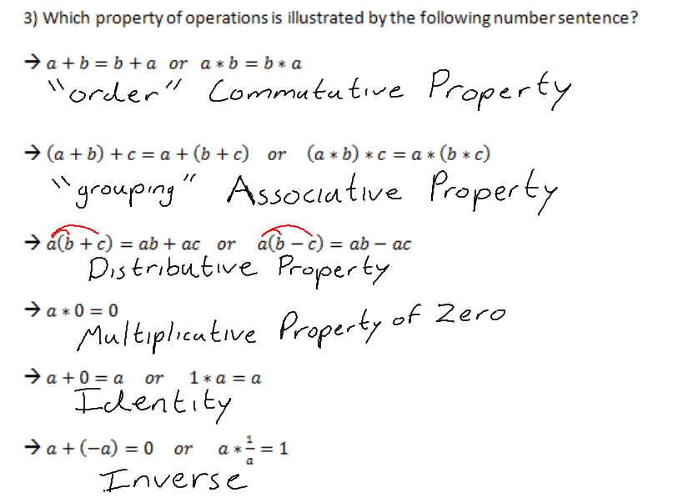 | 