Name: __________________________________________ Block: 1st, 3rd, or 4th Week of: March 10th – 14th, 2014
Monday | Tuesday | Wednesday | Thursday | Friday
1) WITHOUT CALCULATOR  Order from least to greatest:  $$75\%, 0.4,\frac{1}{5}, 2.3×{10}^{-3}$$ | 1) WITHOUT CALCULATOR  Order from least to greatest:  $$\frac{2}{5}, 4×{10}^{-2}, 45\%, 0.3$$ | 1) WITHOUT CALCULATOR  Order from least to greatest:  $$\frac{3}{4}, 15\%, 6.2, 3.4×{10}^{2}$$ | 1) WITHOUT CALCULATOR  Order from least to greatest:  $$250\%,\frac{1}{3}, 0.3, 7.8×{10}^{-1}$$ | 1) WITHOUT CALCULATOR  Order from least to greatest:  $$6.5×{10}^{3}, 65\%, \frac{6}{10}, 0.64$$
2) WITHOUT CALCULATOR  If $x=-5$ and $y=3$, what is the value of $xy-2y$ | 2) WITHOUT CALCULATOR  If $x=-2$ and $y=-4$, what is the value of $-x+xy$ | 2) WITHOUT CALCULATOR  If $x=-7$ and $y=3$, what is the value of $3{(y)}^{2}+x$ | 2) WITHOUT CALCULATOR  If $x=5$ and $y=-25$, what is the value of $\frac{y+x}{4}$ | 2) WITHOUT CALCULATOR  If $x=4$ and $y=7$, what is the value of$6+2x-3y$
3) Solve for x:  $$21-7x=91$$ | 3) Solve for x:  $$9-6x=3$$ | 3) Solve for x:  $$15-x=18$$ | 3) Solve for x:  $$30-5x=20$$ | 3) Solve for x:  $$14-2x=4$$
4) Find the common difference or common ratio of the following sequence:  $$-1,536;384; -96;24;…$$ | 4) Find the common difference or common ratio of the following sequence:  $$-3, -9, -27, -81, …$$ | 4) Find the common difference or common ratio of the following sequence:  $$-17, -13, -9, -5, …$$ | 4) Find the common difference or common ratio of the following sequence:  $$48, 40, 32, 24, …$$ | 4) Find the common difference or common ratio of the following sequence:  $$416, 208, 104, 52, …$$
Helpful Examples To Look to for Help:
1) WITHOUT CALCULATOR  Order from least to greatest:  $$\frac{4}{5}, 0.77, 150\%, 4.3×{10}^{-3}$$  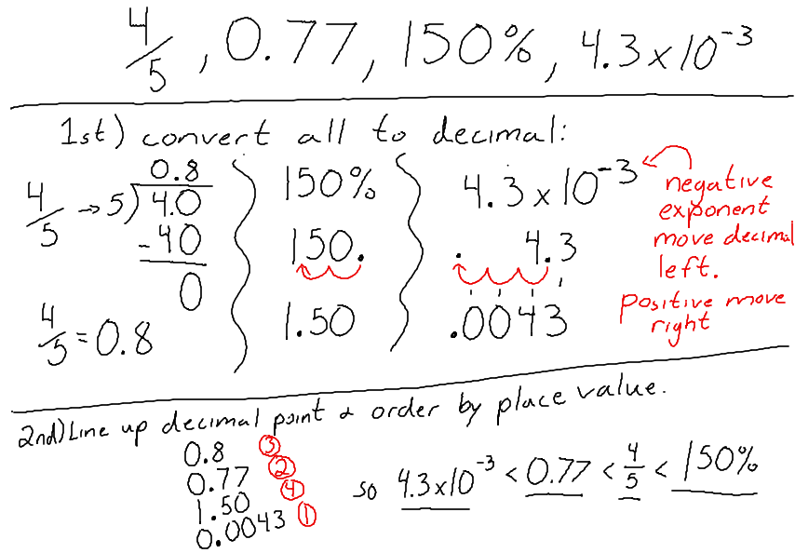 | 2) WITHOUT CALCULATOR  If $x=-6$ and $y=3$, what is the value of: $7+4x-5y$  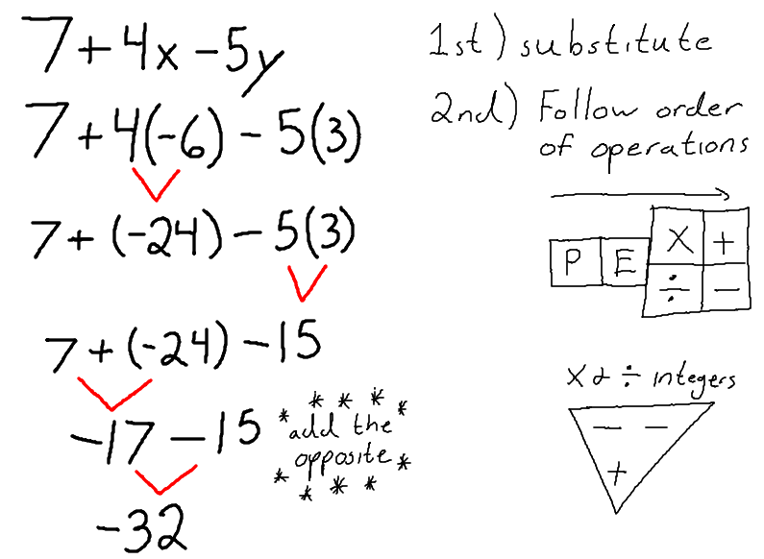
3) Solve for x:  $$32-4x=96$$  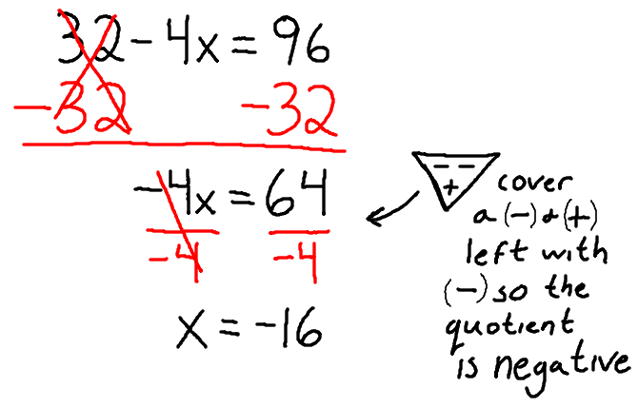 | 4) Find the common difference or common ratio of the following sequence:  EX1) $-32, 16, -8, 4, …$ EX2) $37, 32, 27, 22, …$  