Name: __________________________________________ Block: 1st, 3rd, or 4th Week of: March 31st – April 4th, 2014
Monday | Tuesday | Wednesday | Thursday | Friday
1) NO SCHOOL TODAY | 1) In a survey of 600 people 360 said that their favorite topping is pepperoni. What percentage of the people surveyed said pepperoni was their favorite topping? | 1) In a school with 400 students, 120 ride the bus to school. What percent of the students ride the bus to school? | 1) Mr. Hobbs bought a new shirt. The price of the shirt was $20, and he paid $1.50 in sales tax. What is the sales tax rate? | 1) Mr. Moore ate dinner at a restaurant. The total bill was $35. If he left a tip of $6.30, what percent tip did he leave?
2) NO SCHOOL TODAY | 2) Circle all the ordered pairs that lie on the line represented by:  $$y=6x-2$$  $$\left(0, -2\right) \left(3, 16\right) (-2, -10)$$ | 2) Circle all the ordered pairs that lie on the line represented by:  $$y=-2x+3$$  $$\left(4, -11\right) \left(-3, 9\right) (-5, -7)$$ | 2) Circle all the ordered pairs that lie on the line represented by:  $$y=\frac{x}{5}-2$$  $$\left(0, -2\right) \left(10, 0\right) (-15, -5)$$ | 2) Circle all the ordered pairs that lie on the line represented by:  $$y=-3x-4$$  $$\left(-1, -1\right) \left(-3, -5\right) (4, -16)$$
3) NO SCHOOL TODAY | 3) Write the following statement as an algebraic equation, then solve for the unknown:  “The quotient of a number and nine minus four is six.” | 3) Write the following statement as an algebraic equation, then solve for the unknown:  “The product of a three and a number plus seven is thirty-four.” | 3) Write the following statement as an algebraic equation, then solve for the unknown:  “The quotient of a number and two plus eight is ten.” | 3) Write the following statement as an algebraic equation, then solve for the unknown:  “The product of a twelve and a number minus five is nineteen.”
4) NO SCHOOL TODAY | 4) Identify the transformation:  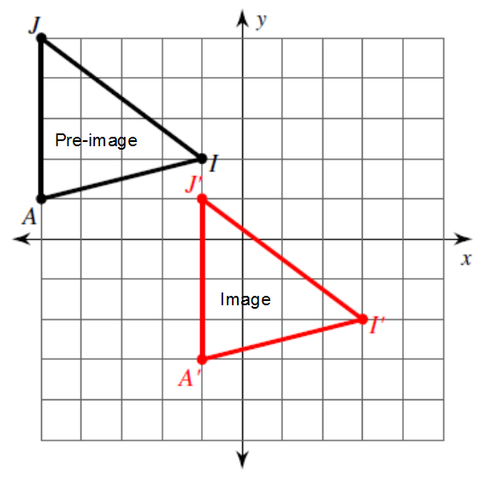 | 4) Identify the transformation:  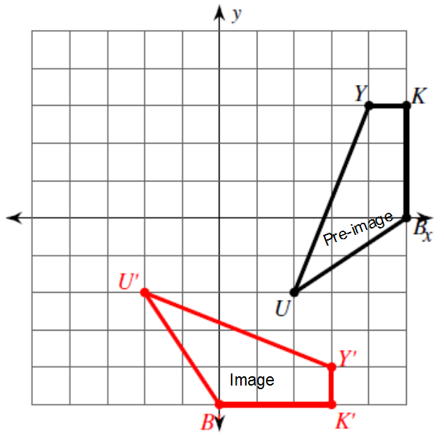 | 4) Identify the transformation:  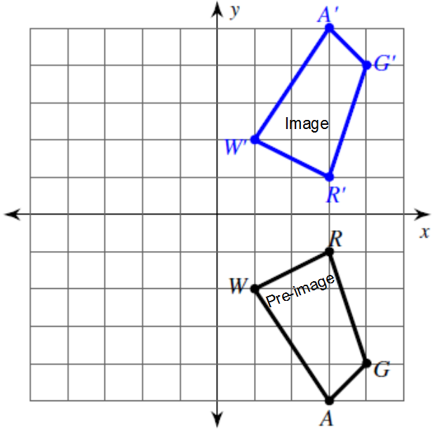 | 4) Identify the transformation:  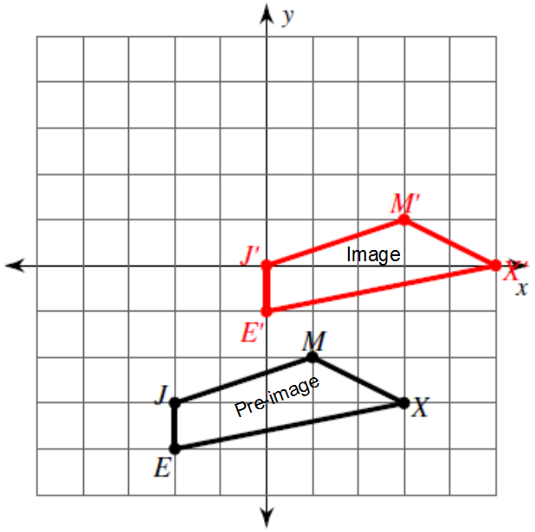

Helpful Examples To Look to for Help:
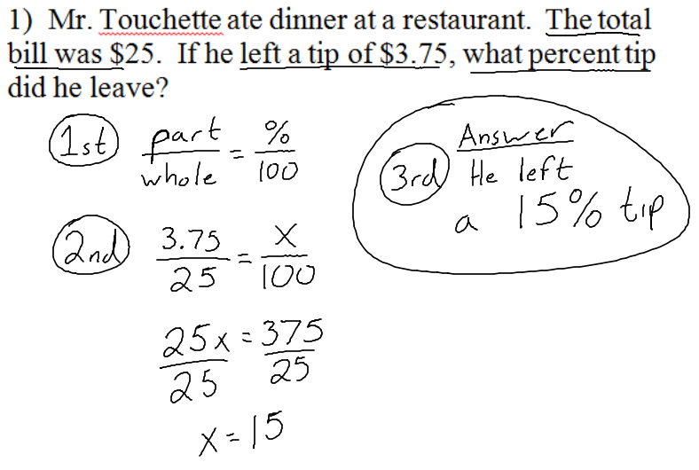 | 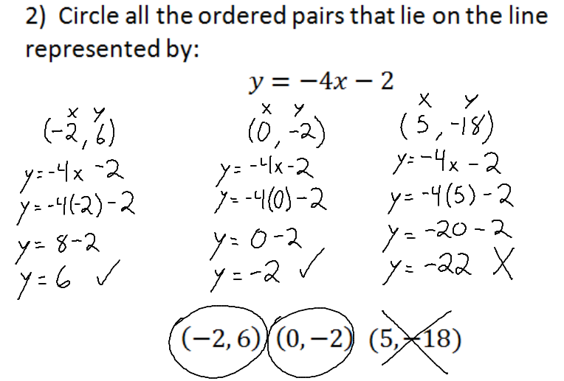
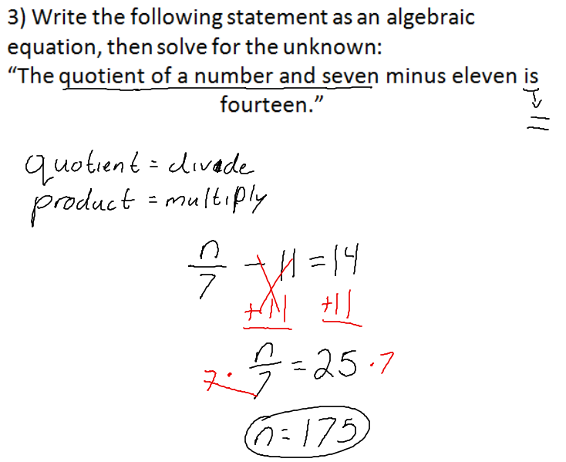 | 4) Identify the transformation:  