Name: __________________________________________ Block: 1st, 3rd, or 4th Week of: February 24th – 28th, 2014
Monday | Tuesday | Wednesday | Thursday | Friday
1) Solve and graph the solution:  $$15+x>10$$  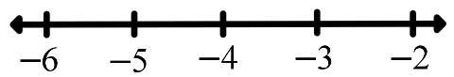 | 1) Solve and graph the solution:  $$x-23≤-10$$  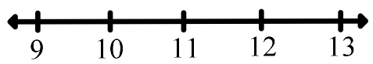 | 1) Solve and graph the solution:  $$9+x<4$$ | 1) Solve and graph the solution:  $$x-14≥-5$$ | 1) Solve and graph the solution:  $$10+x>8$$  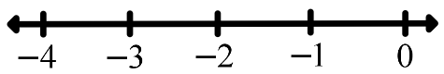
2) Circle all the possible solutions to the inequality below:  $$\frac{x}{-3}≤5$$  $$-15 -16 -14 0 5$$  $$-19 -9 -24 -3$$ | 2) Circle all the possible solutions to the inequality below:  $$-2x>-26$$  $$13 11 9 7 15 17$$  $$-13 0 18 22 12 19$$ | 2) Circle all the possible solutions to the inequality below:  $$\frac{x}{-5}≤2$$  $$-4 -6 -8 -10 -12$$  $$-5 -7 -9 -11 -13$$ | 2) Circle all the possible solutions to the inequality below:  $$-5x<15$$  $$0 3 -3 -7 -1$$  $$2 -10 23 20 -6$$ | 2) Circle all the possible solutions to the inequality below:  $$\frac{x}{-10}≥4$$  $$-30 -40 -50 -60$$  $$-25 -35 -45 -15$$
3) A Wii U, originally priced at $250, was on sale for 10% off. How much will John save? | 3) Best Buy is selling Blue Rays for $19.99. If sales tax is 4.5%, what is the total cost for a Blue Ray? | 3) Ivan’s bill at Chili’s was $23.75. How much money should Ivan leave as a tip if he plans to tip 15%? | 3) Amanda wants to buy rain boots that cost $35. Rue 21 is having a sale on all boots for 30% off. How much will Amanda pay for the boots? | 3) Mr. Dulin buys a bag of candy for $8.25. If sales tax is 6%, what is the total cost including tax?
4) What must the value of x be in order for the figures below to be similar?  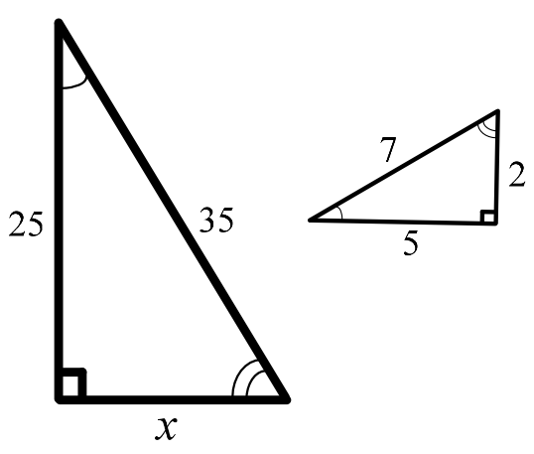 | 4) What must the value of x be in order for the figures below to be similar?  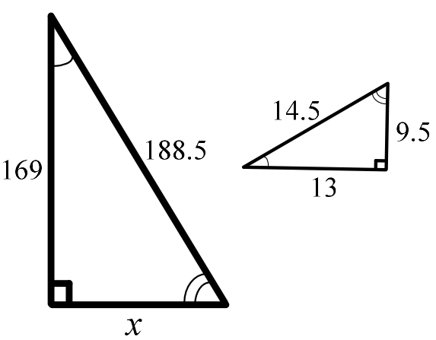 | 4) What must the value of x be in order for the figures below to be similar?  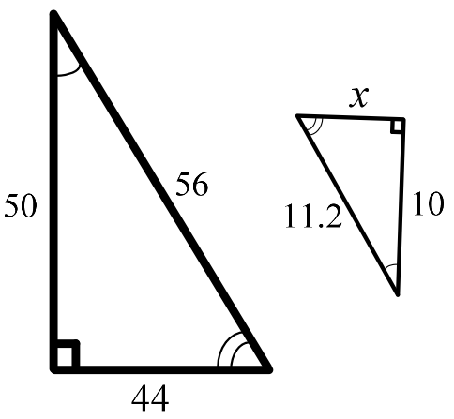 | 4) What must the value of x be in order for the figures below to be similar?  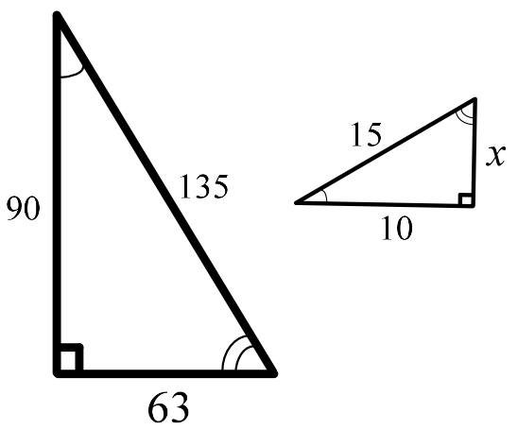 | 4) What must the value of x be in order for the figures below to be similar?  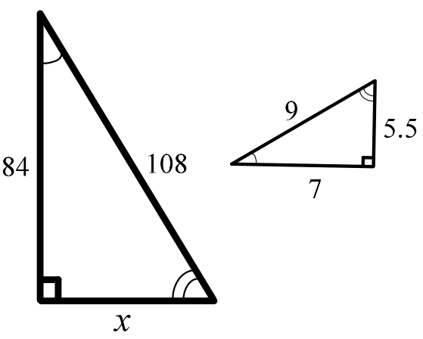

Helpful solutions for weekly problems.
1) Solve and graph the solution:  $8+x>3$ | 2) Circle all the possible solutions to the inequality below:  $$\frac{x}{-7}>5$$  $$-35 -25 -45 -39 -34 -36 -37 -24$$
3) A Wii U, originally priced at $300, was on sale for 20% off. How much will John save? | 4) What must the value of x be in order for the figures below to be similar?  