Name: __________________________________________ Block: 1st, 3rd, or 4th Week of: December 2nd – 6th, 2013 SHOW WORK FOR CREDIT!!!
Monday Dec. 2nd | Tuesday Dec. 3rd | Wednesday Dec. 4th | Thursday Dec. 5th | Friday Dec. 6th
1) Which two sequences use the same variable expression to determine the next term?  #1: $23, 27, 31, 35, 39, 43, …$  #2: $38, 42, 46, 48, 52, 56, …$  #3: $-10, -6, -2, 2, 6, …$  #4: $44, 40, 36, 32, 28, 24, …$ | 1) Nate made the sequence shown using a rule.  $$\frac{1}{9}, -\frac{1}{3},1, -3, …$$  Which term below does not belong? Show work for credit.  A) $9$  B) $-27$  C) $-81$  D) $-243$ | 1) Which two sequences use the same variable expression to determine the next term?  #1: $2, 4, 8, 16, 32, …$  #2: $-3, 6, -12, 24, -48, …$  #3: $\frac{1}{2},-1, 2, -4, 8, …$  #4: $32, 16, 8, 4, 2, …$ | 1) Jessica made the sequence below using a rule.  $$\frac{1}{2},\frac{1}{4},\frac{1}{8},\frac{1}{16},…$$  Which term below does not belong? Show work for credit.  A) $\frac{1}{32}$  B) $\frac{1}{24}$  C) $\frac{1}{64}$  D) $\frac{1}{128}$ | 1) Look at the following sequence:  $$81, 27, 9, 3, …$$  Is the sequence arithmetic or geometric?  What is the common difference or common ratio of the sequence?
2) The table below shows Tia’s hours in class.  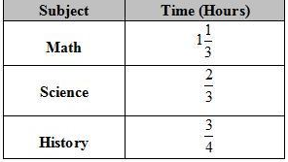  What is the exact amount of time Tia spends in class? | 2) Dylan ran $\frac{4}{7}$ miles each day. How many miles did he run in $5$ days? | 2) Andrew walked $\frac{4}{5}$ mile on Tuesday and $\frac{9}{10}$ mile on Thursday. How many more miles did he walk on Thursday then Tuesday? | 2) Paula Deen’s recipe calls for $2\frac{1}{3}$ sticks of butter for each cake. Paula wants to make 5 cakes. How many sticks of butter will she need? | 2) Jonathon swam $\frac{2}{3}$ mile on Saturday and $\frac{3}{4}$ mile on Sunday. How many miles did he swim altogether?
3) Four students simplified expressions and showed their work. Which student used the associative property of addition? Circle where it takes place.  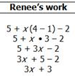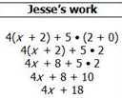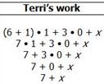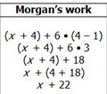 | 3) Four students simplified expressions and showed their work. Which student used the commutative property of multiplication? Circle where it takes place. | 3) Four students were asked to simplify an expression. Which student correctly applied the distributive property?  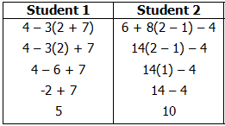  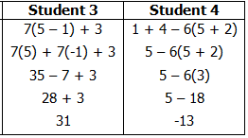 | 3) Four students were asked to simplify an expression. Which student incorrectly applied the additive identity property?  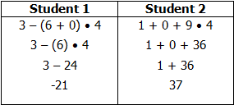  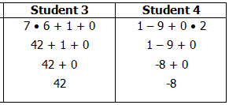 | 3) Raquon wrote these steps when simplifying an expression.  Step 1: $13+\left(47+15\right)$  Step 2: $\left(13+47\right)+15$  Step 3: $60+15$  Step 4: $75$  Which property justifies step 1 to step 2?
4) Complete the table and graph.  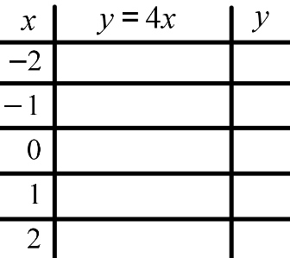  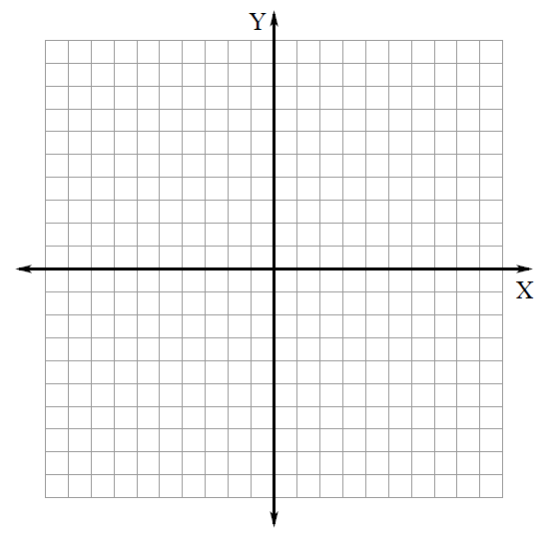 | 4) Complete the table and graph.  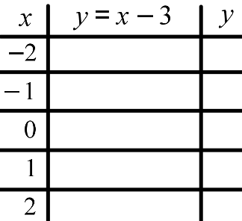 | 4) Complete the table and graph.  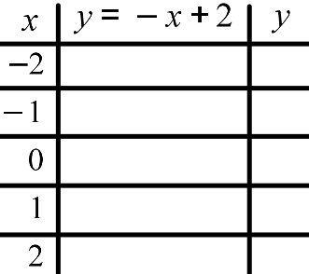 | 4) Complete the table and graph.  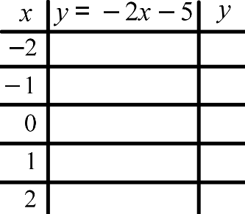 | 4) Complete the table and graph.  