Name: __________________________________________ Block: 1st, 3rd, or 4th Week of: April 28th – May 2nd, 2014
Helpful Examples | Monday | Tuesday | Wednesday | Thursday
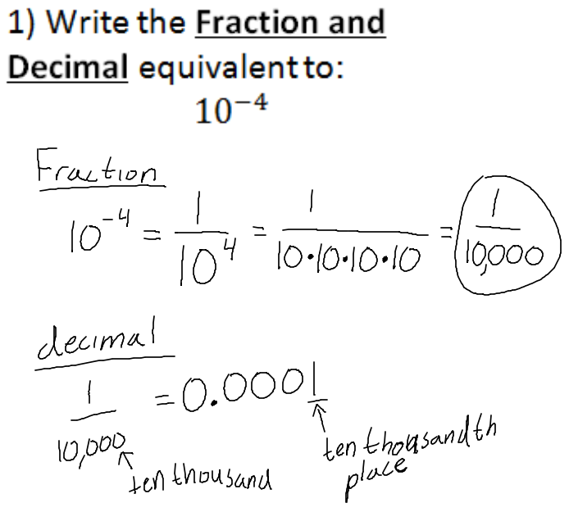 | 1) Write the Fraction and Decimal equivalent to:  $${10}^{-3}$$ | 1) Write the Fraction and Decimal equivalent to:  $${10}^{-1}$$ | 1) Write the Fraction and Decimal equivalent to:  $${10}^{0}$$ | 1) Write the Fraction and Decimal equivalent to:  $${10}^{-5}$$
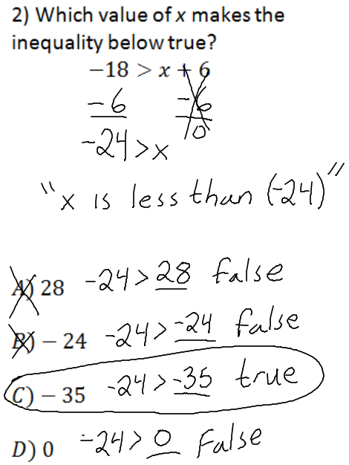 | 2) Which value of x makes the inequality below true?$$\frac{x}{-3}>(-10)$$  $$A) 30$$  $$B) 40$$  $$C) 31$$  $$D) 25$$ | 2) Which value of x makes the inequality below true?  $$-25<5x$$  $$A) 15$$  $$B)-5$$  $$C)-30$$  $$D)-8$$ | 2) Which value of x makes the inequality below true?  $$-12>x-8$$  $$A)-4$$  $$B)-12$$  $$C) 20$$  $$D)-1$$ | 2) Which value of x makes the inequality below true?  $$56<\left(-8\right)x$$  $$A) 0$$  $$B) 64$$  $$C)-17$$  $$D)-7$$
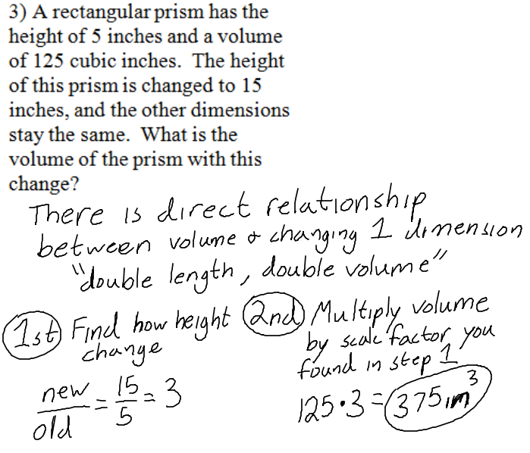 | 3) A rectangular prism has the width of 6 inches and a volume of 108 cubic inches. The width of this prism is changed to 12 inches, and the other dimensions stay the same. What is the volume of the prism with this change? | 3) A rectangular prism has the length of 4 meters and a volume of 80 cubic meters. The length of this prism is changed to 16 meters, and the other dimensions stay the same. What is the volume of the prism with this change? | 3) A rectangular prism has the height of 7 feet and a volume of 42 cubic feet. The height of this prism is changed to 3.5 feet, and the other dimensions stay the same. What is the volume of the prism with this change? | 3) A rectangular prism has the width of 12 inches and a volume of 144 cubic inches. The width of this prism is changed to 3 inches, and the other dimensions stay the same. What is the volume of the prism with this change?
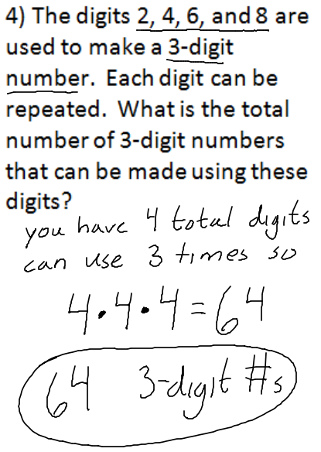 | 4) The digits 1, 2, and 3 are used to make a 3-digit passcode. Each digit can be used more than once. What is the total number of 3-digit passcodes that can be made using these digits? | 4) The digits 0, 1, 2, 3, 4, 5, 6, 7, 8, and 9 can be used to make a 4-digit passcode on your iPhone. Each digit can be repeated. What is the total number of 4-digit passcodes that can be made using these digits? | 4) Cooper is taking a test with 15 true/false questions. How many possible ways can the fifteen answers appear on the test? | 4) A spinner has sections labeled A, B, C, and D. The faces of a number cube are labeled 1 – 6. A coin has two sides, heads or tails. What is the total number of possible outcomes of 1 spin of the spinner, 1 roll of the die, and 1 flip of the coin?

