Name: __________________________________________ Block: 1st, 3rd, or 4th Week of: April 7th – 11th, 2014
Monday | Tuesday | Wednesday | Thursday | Friday
1) Find the volume of the cylinder:  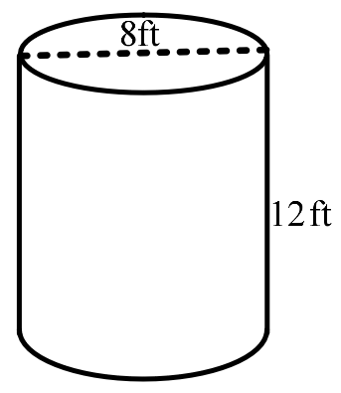 | 1) Find the volume of the cylinder:  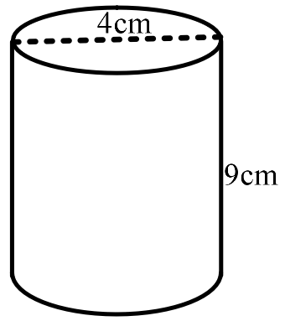 | 1) Find the volume of the cylinder:  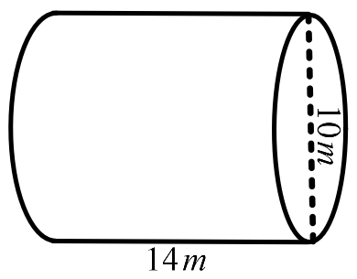 | 1) Find the volume of the cylinder:  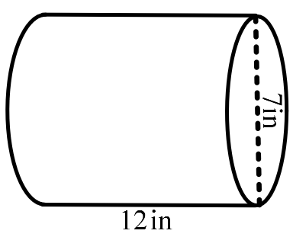 | 1) Find the volume of the cylinder:  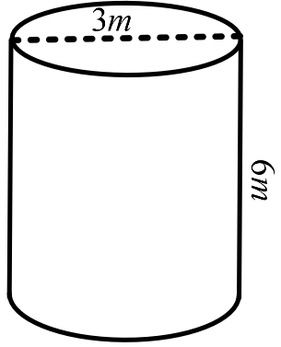
2) Name the two figures and circle all the classifications that describe both of these figures?  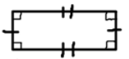  Quadrilateral Trapezoid  Parallelogram Rectangle Rhombus Square | 2) Name the two figures and circle all the classifications that describe both of these figures?  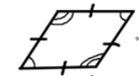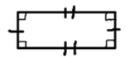  Quadrilateral Trapezoid  Parallelogram Rectangle Rhombus Square | 2) Name the two figures and circle all the classifications that describe both of these figures?  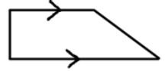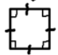  Quadrilateral Trapezoid  Parallelogram Rectangle Rhombus Square | 2) Name the two figures and circle all the classifications that describe both of these figures?  Quadrilateral Trapezoid  Parallelogram Rectangle Rhombus Square | 2) Name the two figures and circle all the classifications that describe both of these figures?  Quadrilateral Trapezoid  Parallelogram Rectangle Rhombus Square
3) Identify each property illustrated by the equation:  $$10+\left(-10\right)=0$$ | 3) Identify each property illustrated by the equation:  $$2*\left(3+8\right)=\left(3+8\right)*2$$ | 3) Identify each property illustrated by the equation:  $$1*\left(4+6\right)=(4+6)$$ | 3) Identify each property illustrated by the equation:  $$8\left(3-5\right)=8\left(3\right)-8(5)$$ | 3) Identify each property illustrated by the equation:  $$\left(-1*5\right)+6=6+(-1*5)$$
4) Graph the solution of the inequality on the number line:  $$-3x<9$$ | 4) Graph the solution of the inequality on the number line:  $$x-5≤(-1)$$ | 4) Graph the solution of the inequality on the number line:  $$x-4<(-3)$$ | 4) Graph the solution of the inequality on the number line:  $$-10x≤50$$ | 4) Graph the solution of the inequality on the number line:  $$-9x≥(-63)$$

Helpful Examples To Look to for Help:
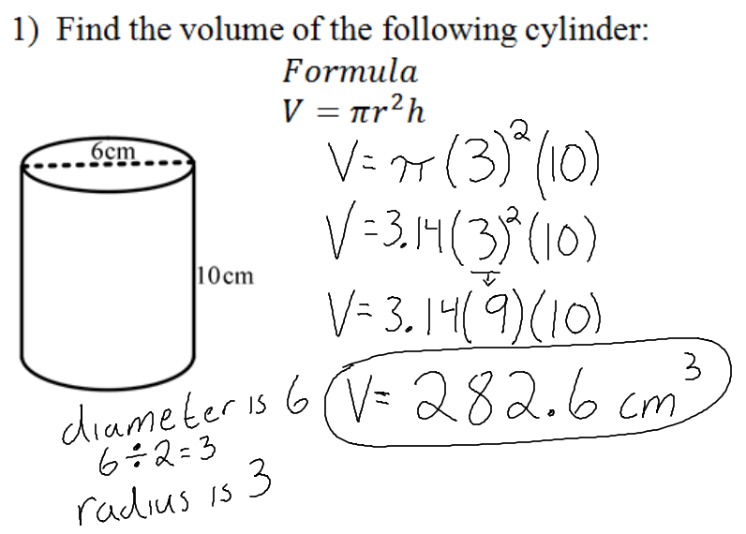 | 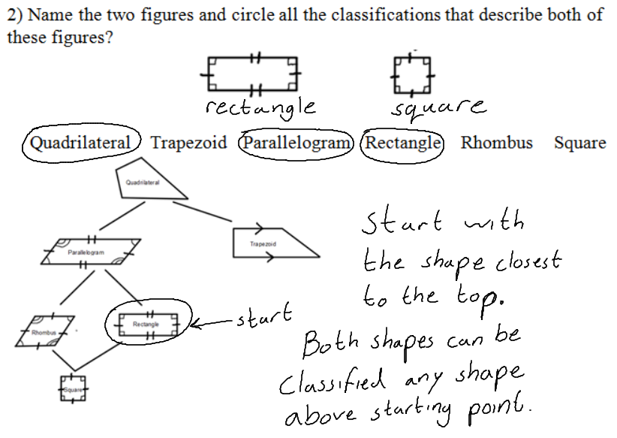
3) List and Examples of each Property of Operations:  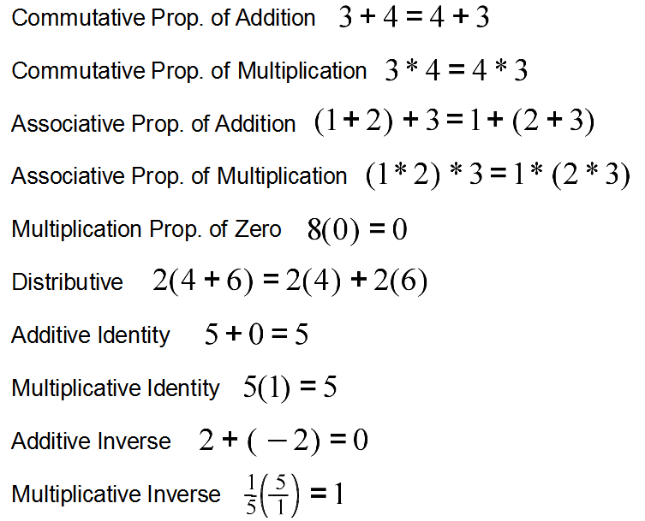 | 