Name: __________________________________________ Block: 1st, 3rd, or 4th Week of: April 21st – 25th, 2014
Helpful Examples | Monday | Tuesday | Friday
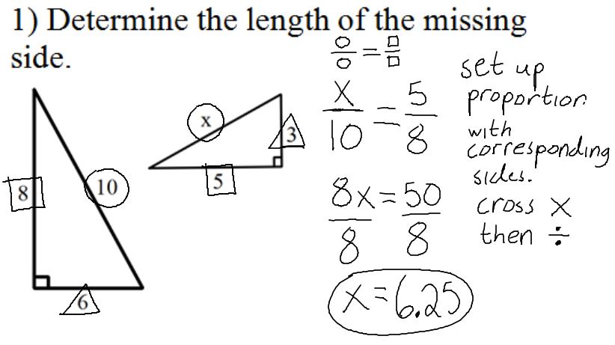 | 1) Determine the length of the missing side.  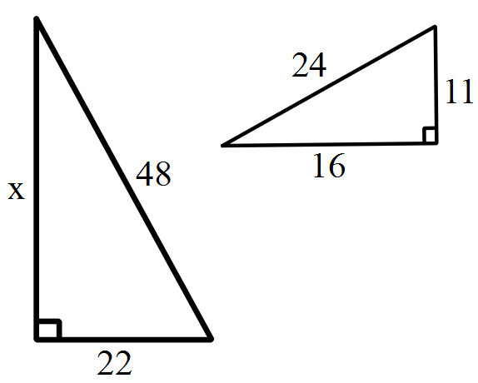 | 1) Determine the length of the missing side.  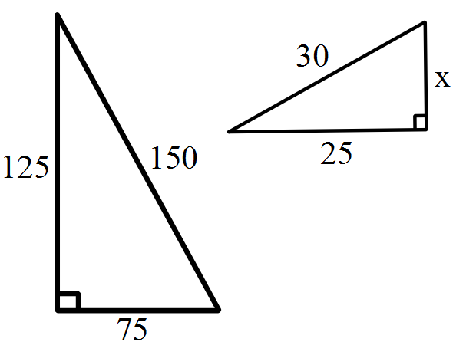 | 1) Determine the length of the missing side.  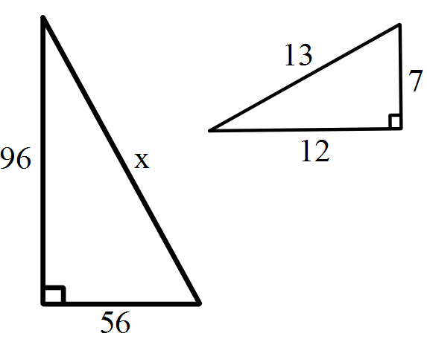
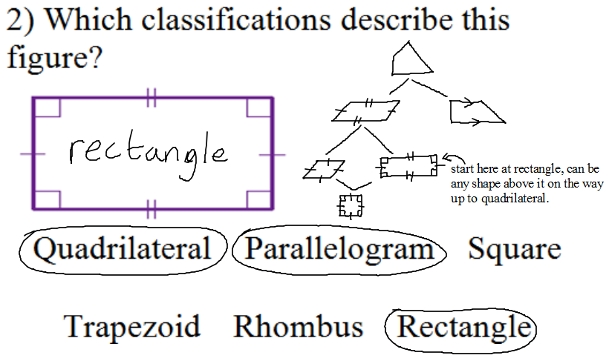 | 2) Which classifications describe this figure?  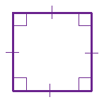  Quadrilateral Parallelogram Square  Trapezoid Rhombus Rectangle | 2) Which classifications describe this figure?  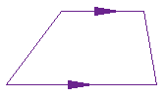  Quadrilateral Parallelogram Square  Trapezoid Rhombus Rectangle | 2) Which classifications describe this figure?  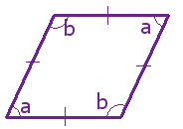  Quadrilateral Parallelogram Square  Trapezoid Rhombus Rectangle
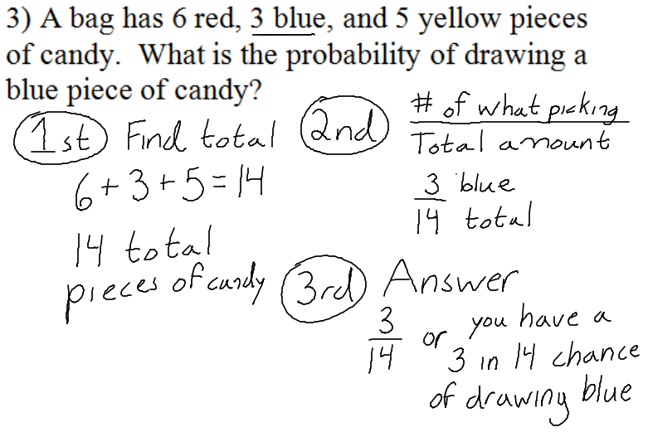 | 3) A spinner consists of 2 red spaces, 3 green spaces, and 3 purple spaces. What is the probability of landing on a green space? | 3) The faces of a fair 6-sided cube are numbered 1 through 6. The number cube is rolled. What is the probability it will land on a 2? | 3) Phil has a basket of 6 red balls, 4 yellow balls, and 3 green balls. What is the probability that he will randomly grab a red ball out of the basket?
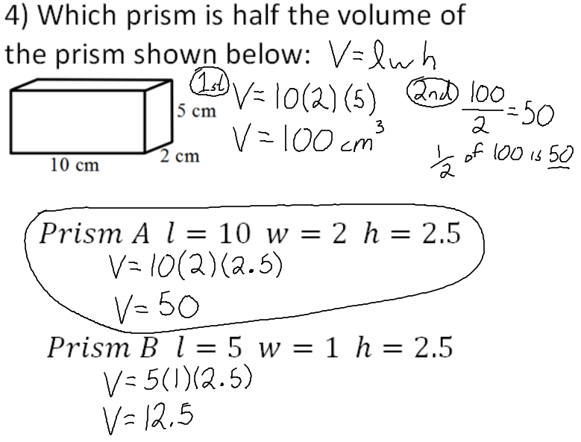 | 4) Which prism is half the volume of the prism shown below:  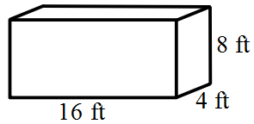  $$Prism A l=16 w=2 h=4$$  $$Prism B l=8 w=4 h=8$$ | 4) Which prism is half the volume of the prism shown below:  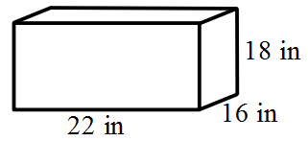  $$Prism A l=11 w=16 h=9$$  $$Prism B l=22 w=8 h=18$$ | 4) Which prism is half the volume of the prism shown below:  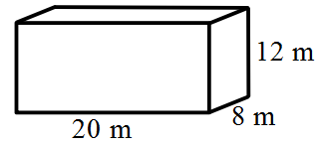  $$Prism A l=10 w=8 h=12$$  $$Prism B l=10 w=4 h=6$$

