Unit 4 Study Guide Name: ____________________________________________________
1) Solve:  $$23=\frac{x}{5}$$ | 2) Solve:  $$7m+11=60$$ | 3) Solve:  $$35=15-4n$$ | 4) Solve:  $$\frac{-x}{2}=13$$
5) Solve:  $$\frac{x-5}{10}=-3$$ | 6) Solve:  $$\frac{2}{3}x-4=2$$ | 7) Copper burned 720 calories today when running. This was 65 calories more than he burned yesterday. How many calories did Copper burn yesterday? | 8) Sam is $\frac{1}{5}$ his dad’s age. If Sam is 7 years old, how old is his dad?
9) Trey needs to write a total of 500 words for an English essay. He currently has $\frac{1}{4}$ of the total paper done. How many more words does Trey need to write to be finished with his essay? | 10) Which values for x make the following true?  $$-6>-4+x$$  $$A) x>-10$$  $$B) x<-10$$  $$C) x>-2$$  $$D) x<-2$$ | 11) Which represents all the values for x that make the following true?  $$-6x≥60$$  $$A) x≥-10$$  $$B) x≤-10$$  $$C) x≥66$$  $$D) x≤66$$ | 12) What is a value of x that makes the following true?  $$-4x<28$$  $$A)-6$$  $$B)-7$$  $$C)-8$$  $$D)-9$$

13) Look at the equation shown in the model:  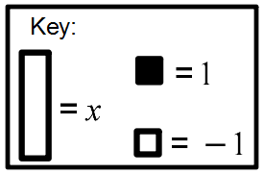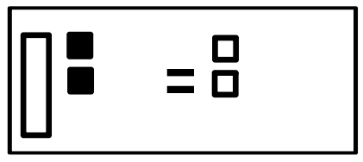  Which model shows the next step in solving the equation?  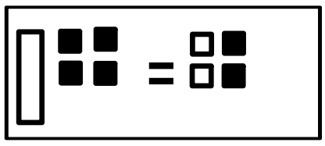  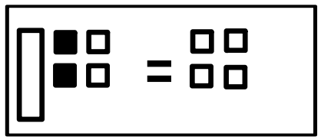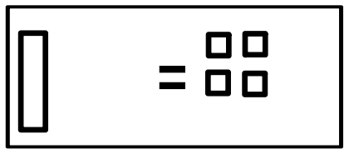 | 14) Using the key shown, identify each model where x has a value of 2.  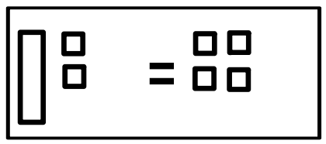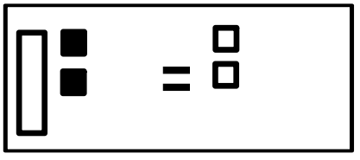  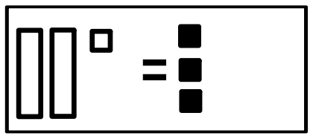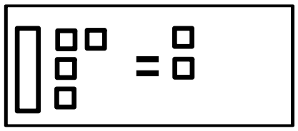 | 15)  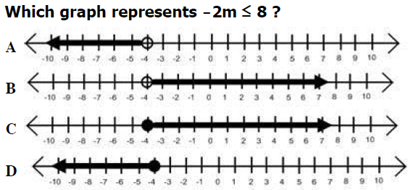
16)  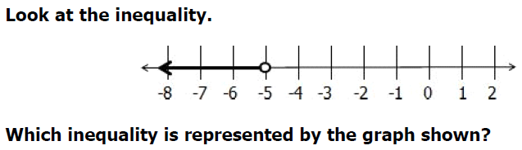  $$A) 12<x+7 B)-12>x-7$$  $$C) 12>x+7 D)-12<x-7$$ | 17)  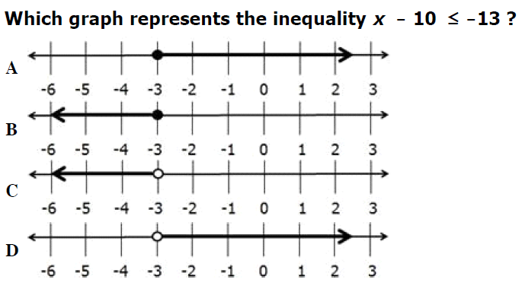 | 18) Select all the possible solutions for the inequality below?  $$8+x<-2$$  $$10 -9 -12 0 -4$$  $$-10 -17 -21 -7 12$$  $$-13 -39 -8 -2 15$$

