Unit 5 Study Guide Due Date: Wednesday Feb. 26th Name: ___________________________________________________________
1) Logan is making a scale model of a Ford Mustang. The actual Ford Mustang is 7 feet wide by 16 feet long. If the model is 10 inches long, how wide does the model need to be? | 2) Kaylee is building a model of her tree house. The actual tree house is 20 feet wide by 35 feet long. If the model is 13 inches long, how wide does the model need to be? | 3) A map has a scale of 3 centimeters = 9 kilometers. Orange and Culpeper are 15 centimeters apart on the map. How far apart are the two towns in real life? | 4) A map has a scale of 1.5 inches = 5 miles. Culpeper and Madison are 7.5 inches apart on the map. How far apart are the two towns in real life?
5) Which of the following is a proportion?  A) 3 to 5 = 9 to 20  B) 6 to 5 = 42 to 35  C) 1 to 3 = 8 to 32 | 6) Which of the following is a proportion?  A) 4 to 7 = 44 to 70  B) 8 to 3 = 56 to 24  C) 7 to 9 = 17.5 to 22.5 | 7) Matt correctly answered 80% of the questions on his science test in Mr. George’s class. If he answered 14 questions correctly, how many questions were on the test? | 8) Tia correctly answered 87% of the questions on her history quiz in Mrs. Sheads’ class. If she answered 13 questions correctly, how many questions were on the test?
9) Alex is buying Mario Kart. Mario Kart costs $46.99, and the sales tax rate is 5%. What is the total cost Alex will pay for Mario Kart? | 10) Kirby is buying Super Smash Bros, Brawl. Brawl costs $36.75, and the sales tax rate is 4.5%. What is the total cost Kirby will pay for Super Smash Bros. Brawl? | 11) Will’s bill at Bob’s Burgers is $13.00. How much money should Will leave as a tip if he plans to tip 20%? | 12) Patrick’s bill at The Krusty Krab was $7.88. How much money should Patrick leave as a tip if he plans to tip 15%?

13) A MacBook, originally priced at $350, was on sale for 25% off. What is the sale price of the MacBook? | 14) A Kindle Fire, originally priced at $175, was on sale for 15% off. What is the sale price of the Kindle Fire? | 15) Peggy Hill buys a box of Fruit Loops for $3.65, a loaf of Wonder Bread for $2.19, and 2 bags of Lays Bar-B-Q chips for $1.25 a bag. If sales tax is 5%, what is the total cost including tax? | 16) Marge Simpson buys a box of Eggo Waffles for $4.50, a bag of shredded cheese for $3.75, and 2 bottles of maple syrup for $1.95 a bottle. If sales tax is 3%, what is the total cost including tax?
17) The following is true about similar triangles ABC and XYZ.  $$\frac{AB}{XY}=\frac{BC}{YZ}=\frac{AC}{XZ}=\frac{3}{5}$$  Which choice could be possible lengths of $\overline{BC}$ and $\overline{YZ}$?  A) BC = 21, YZ = 30  B) BC = 12.6, YZ = 21 | 18) The following is true about similar triangles ABC and XYZ.  $$\frac{AB}{XY}=\frac{BC}{YZ}=\frac{AC}{XZ}=\frac{9}{7}$$  Which choice could be possible lengths of $\overline{BC}$ and $\overline{YZ}$?  A) BC = 45, YZ = 35  B) BC = 27, YZ = 28 | 19) Based on the figures below, are they similar?  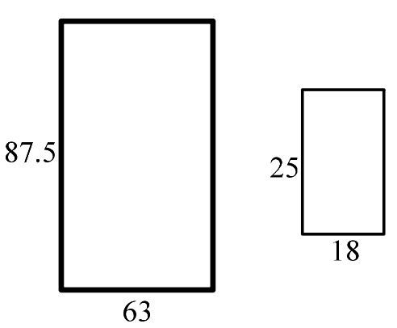 | 20) Based on the figures below, are they similar?  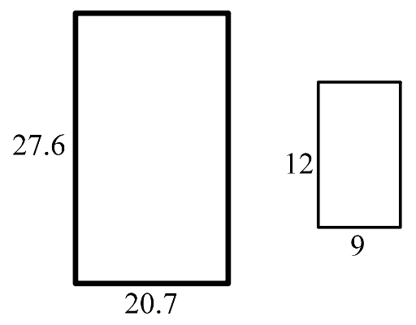
21) Are the two triangles similar?  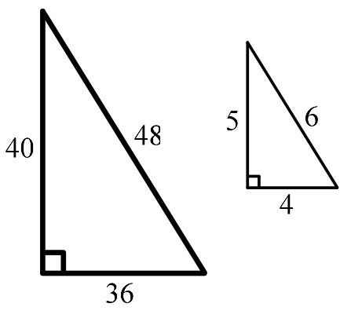 | 22) Are the two triangles similar?  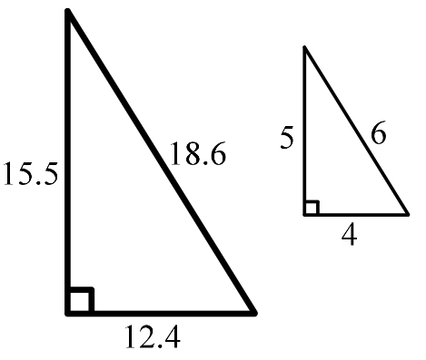 | 23) What must the value of x be in order for the figures below to be similar?  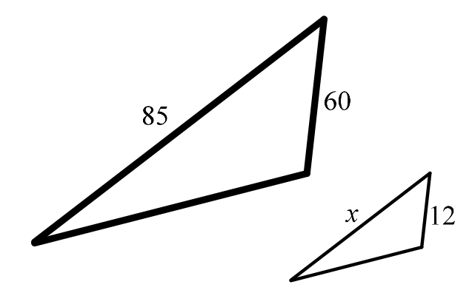 | 24) What must the value of x be in order for the figures below to be similar?  